**ITCS222**

**Computer Organization and Architecture**

**Programming Project 1**

Waris Damkham 6388014

Section 1

**Assoc. Prof. Dr. Chomtip Pornpanomchai**

**Ascending sort three integers: C language**

**Code:**

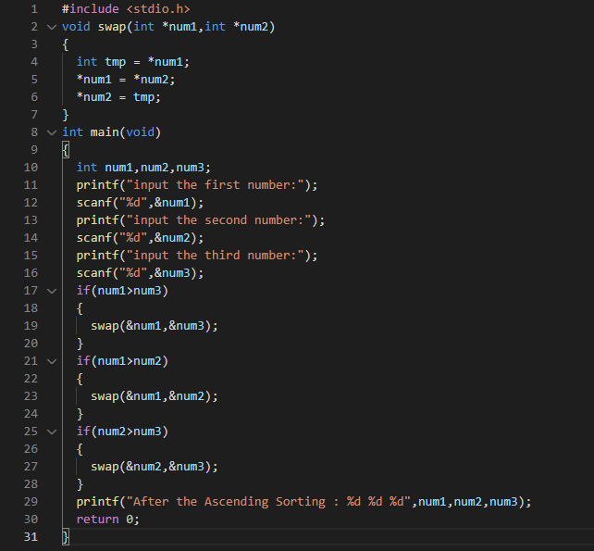

**The Output:**

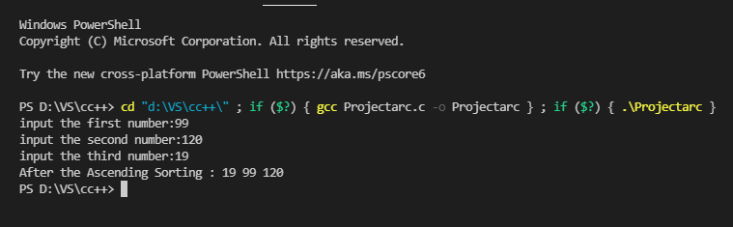

**Ascending sort three integers: Assembly language**

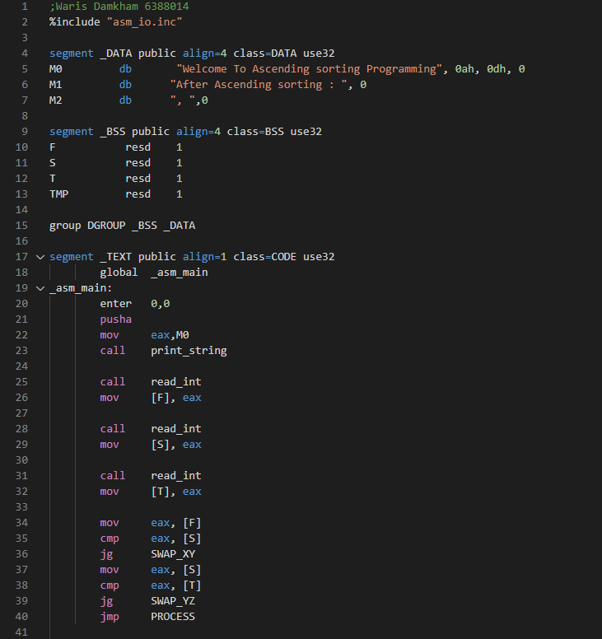**Code:**

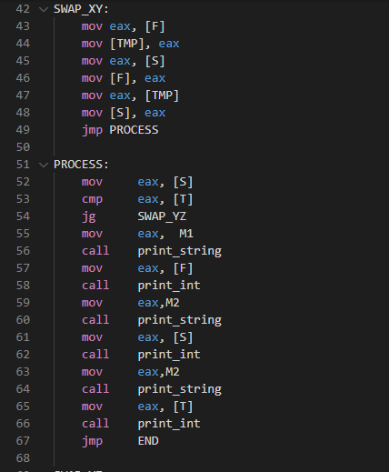

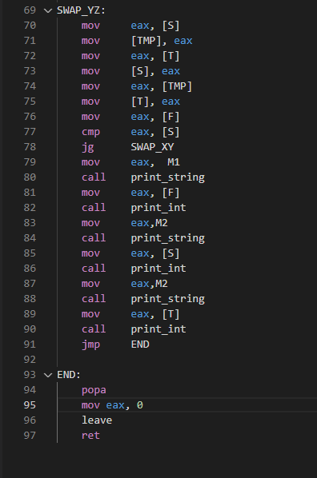

**The Output:** 